ASSIGNMENT NO 1

SUPERSTORES EXERCISE:

1. Write a query to display the Customer_Name and Customer Segment using alias name “Customer Name", "Customer Segment" from table Cust_dimen.

Query:

select Customer_Name as "Customer Name",

Customer_Segment as " Customer Segment"

from cust_dimen;

output:

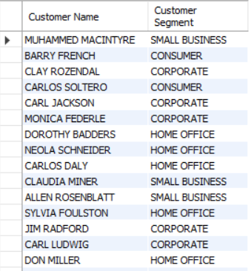

2.Write a query to find all the details of the customer from the table cust_dimen order by desc.

Query:

select *

from cust_dimen

order by customer_Name DESC;

Output:

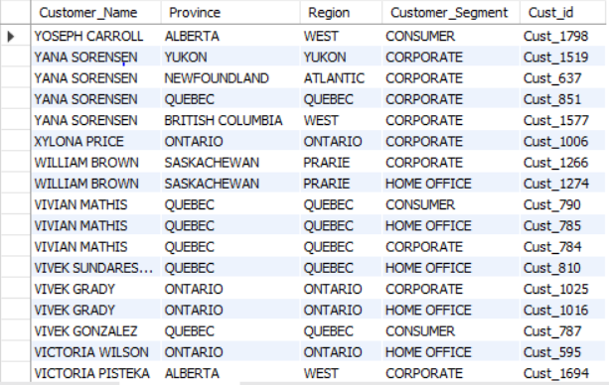

3.Write a query to get the Order ID, Order date from table orders_dimen where ‘Order Priority’ is high.

Query:

select Order_ID,Order_Date,

from orders_dimen

where order_Priority = "high";

Output:

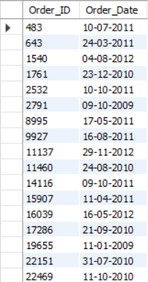

Query:

select Order_ID,Order_Date,Order_Priority

from orders_dimen

where order_Priority = "high";

Output:

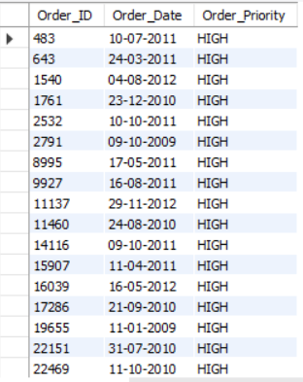

4. Find the total and the average sales (display total_sales and avg_sales)

Query:

select sum(sales) as Total_sales,

Avg(sales) as Avg_sales

from market_fact;

Output:



5. Write a query to get the maximum and minimum sales from maket_fact table.

Query:

select max(sales)as maiximum_sales,

min(sales)as minimum_sales

from market_fact;

Output:



6. Display the number of customers in each region in decreasing order of no_of_customers. The result should contain columns Region, no_of_customers.

Query:

select Region,count(*)"No_Of_Customer" from cust_dimen group by region order by No_Of_Customer;

Output:

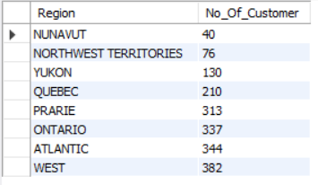

7. Find the region having maximum customers (display the region name and max(no_of_customers)

Query:

select region,count(*)" max_no_of_customer" from cust_dimen group by region

having max_no_of_customer >= all (select count(*)"max_no_of_customer" from cust_dimen group by region);

Output:

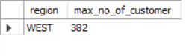

8. Find all the customers from Atlantic region who have ever purchased ‘TABLES’ and the number of tables purchased (display the customer name, no_of_tables purchased)

Query:

select c.Customer_Name,count(*)"no_fo_tables_purchased"

from market_fact m inner join cust_dimen c on m.cust_id = c.cust_id

where c.region = 'atlantic' and m.prod_id = (select prod_id from prod_dimen where product_sub_category ='tables') group by m.cust_id,c.customer_name;

Output:

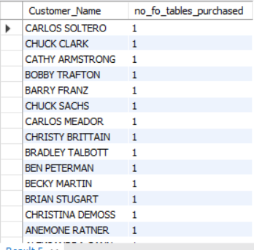

9. Find all the customers from Ontario province who own Small Business. (display the customer name, no of small business owners)

Query:

select Customer_Name,Province,

Customer_Segment as no_of_small_Business_owners

from cust_dimen

where Province="Ontario" and Customer_Segment="Small Business";

Output:

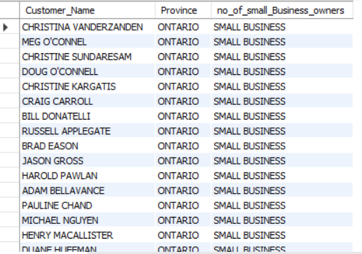

10. Find the number and id of products sold in decreasing order of products sold (display product id, no_of_products sold)

Query:

select Prod_id, count(*) as no_of_products_sold from market_fact group by prod_id order by no_of_products_sold desc;

Output:

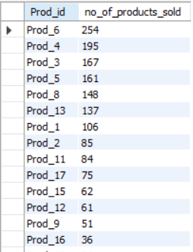

12. Display the product categories in descending order of profits (display the product category wise profits i.e. product_category, profits)?

Query:

select Product_Category,Profit from market_fact natural join prod_dimen order by Profit desc;

Output:

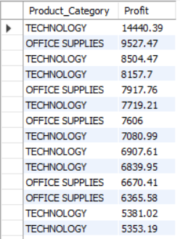

13. Display the product category, product sub-category and the profit within each subcategory in three columns.

Query:

select p.Product_Category,p.Product_Sub_Category,sum(m.Profit) "profits"

from market_fact m inner join prod_dimen p on m.prod_id = p.prod_id group by p.Product_Category,p.Product_Sub_Category;

Output:

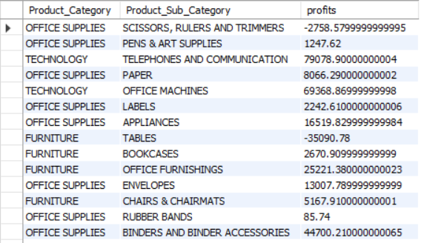

14. Display the order date, order quantity and the sales for the order

Query:

select Order_Date,Order_Quantity,Sales from market_fact natural join orders_dimen;

Output:

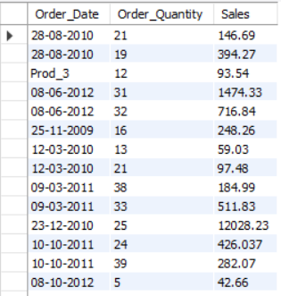

15.Display the names of the customers whose name contains the

i) Second letter as ‘R’

Query:

select Customer_Name

from cust_dimen

where Customer_Name like'_R%'

Output:

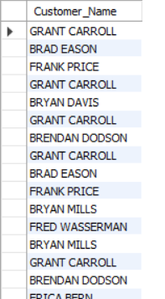

ii) Fourth letter as ‘D’

Query:

select Customer_Name

from cust_dimen

where Customer_Name like'___D%'

Output:

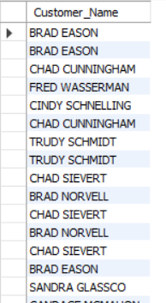

17. Write a SQL query to find the 3rd highest sales.

Query:

select sales

from market_fact

order by sales

desc limit 2,1;

Output:

